**Supplementary Material**



**Figure 1**: The chromatography of spearmint essential oil analyzed by GC-MS.

|  |  |
| --- | --- |
| **Readout** | **Description** |
| **CCL2/MCP-1** | MCP-1 system is a chemokine that mediates recruitment of monocytes and T cells into sites of inflammation. MCP-1 is categorized as an inflammation related activity in the HDF3CGF system modeling Th1 inflammation involved in wound healing and matrix remodeling. |
| **CD106/VCAM-1** | VCAM-1 is a cell adhesion molecule that mediates adhesion of monocytes and T cells to endothelial cells. VCAM-1 is categorized as an inflammation-related activity. |
| **CD54/ICAM-1** | ICAM-1 is a cell adhesion molecule that mediates leukocyte-endothelial cell adhesion and leukocyte recruitment. ICAM-1 is categorized as an inflammation-related activity. |
| **Collagen I** | Collagen I is involved in tissue remodeling and fibrosis, and is the most common fibrillar collagen that is found in skin, bone, tendons and other connective tissues. Collagen I is categorized as a tissue remodeling-related activity. |
| **Collagen III** | Collagen III is an extracellular matrix protein and fibrillar collagen found in extensible connective tissues (skin, lung and vascular system) and is involved in cell adhesion, cell migration, tissue remodeling. Collagen III is categorized as a tissue remodeling-related activity. |
| **CXCL10/IP-10** | IP-10 is a chemokine that mediates T cell, monocyte and dendritic cell chemotaxis. IP-10 is categorized as an inflammation-related activity. |
| **CXCL11/I-TAC** | I-TAC is a chemokine that mediates T cell and monocyte chemotaxis. I-TAC is categorized as an inflammation-related activity. |
| **CXCL8/IL-8** | IL-8 is a chemokine that mediates neutrophil recruitment into acute inflammatory sites. IL-8 is categorized as an inflammation-related activity. |
| **CXCL9/MIG** | MIG is a chemokine that mediates T cell recruitment. MIG is categorized as an inflammation-related activity. |
| **EGFR** | EGFR is a cell surface receptor for epidermal growth factor involved in cell proliferation during development as well as tumor growth. EGFR is involved in Epithelial cell proliferation, epithelial cell differentiation keratinocyte proliferation, tissue remodeling. EGFR is categorized as a tissue remodeling-related activity. |
| **M-CSF** | M-CSF is a secreted and cell surface cytokine that mediates macrophage differentiation. M-CSF is categorized as animmune modulation-related activity. |
| **MMP-1** | MMP-1 is an interstitial collagenase that degrades collagens I, II and III and is involved in the process of tissue remodeling. MMP-1 is categorized as a tissue remodeling-related activity. |
| **PAI-I** | PAI-I is a serine proteinase inhibitor and inhibitor of tissue Plasminogen Activator (tPA) and urokinase (uPA) and is involved in tissue remodeling and fibrinolysis. PAI-I is categorized as a tissue remodeling-related activity. |
| **Proliferation 72hr** | Proliferation 72hr in the HDF3CGF system is a measure of dermal fibroblast proliferation which is important to the process of wound healing and fibrosis. |
| **SRB** | SRB is a measure of the total protein content of dermal fibroblasts. Cell viability of adherent cells is measured by Sulforhodamine B (SRB) staining, a method that determines cell density by measuring total protein content of test wells. |
| **TIMP-1** | TIMP-1 is a tissue inhibitor of Matrix Metalloprotease-7 (MMP-7) and other MMPs, and is involved in tissue remodeling, angiogenesis and fibrosis. TIMP-1 is categorized as a tissue remodeling-related activity. |
| **TIMP-2** | TIMP-2 is a tissue inhibitor of matrix metalloproteases and is involved in tissue remodeling, angiogenesis and fibrosis. TIMP-2 is categorized as a tissue remodeling-related activity. |

**Table 1:** Glossary of biomarkers of the human dermal fibroblast system (HDF3CGF) used in the study.

|  |  |  |
| --- | --- | --- |
| **Illumina Gene ID** | **Fold Change in Log2 form** | **Definition** |
| TFRC | 2.69 | *Homo sapiens* transferrin receptor (p90, CD71) (TFRC), mRNA. |
| AKR1C4 | 2.33 | *Homo sapiens* aldo-keto reductase family 1, member C4 (chlordecone reductase; 3-alpha hydroxysteroid dehydrogenase, type I; dihydrodiol dehydrogenase 4) (AKR1C4), mRNA. |
| GSTA2 | 2.13 | *Homo sapiens* Glutathione S-Transferase A2 (GSTA2), mRNA. |
| CDCA7 | 2.05 | *Homo sapiens* Cell Division Cycle Associated 7 (CDCA7), transcript variant 1, mRNA. |
| TSPAN13 | 1.96 | *Homo sapiens* Tetraspanin 13 (TSPAN13), mRNA. |
| HS.527671 | 1.82 | UI-CF-FN0-age-p-21-18-UI.r18 UI-CF-FN0 *Homo sapiens* cDNA clone UI-CF-FN0-age-p-21-18-UI 5, mRNA sequence |
| MIR1914 | 1.81 | *Homo sapiens* microRNA 1914 (MIR1914), microRNA. |
| HNRNPA1 | 1.80 | *Homo sapiens* Heterogeneous Nuclear Ribonucleoprotein A1 (HNRNPA1), transcript variant 2, mRNA. |
| LOC650922 | 1.79 | PREDICTED: *Homo sapiens* hypothetical LOC650922 (LOC650922), mRNA. |
| HS.544326 | 1.74 | hd38d03.x1 Soares_NFL_T_GBC_S1 *Homo sapiens* cDNA clone IMAGE:2911781 3, mRNA sequence. |
| HNRPH1 | 1.74 | *Homo sapiens* Heterogeneous Nuclear Ribonucleoprotein H1 (H) (HNRPH1), mRNA. |
| FGF6 | 1.71 | *Homo sapiens* Fibroblast Growth Factor 6 (FGF6), mRNA. |
| HS.374832 | 1.71 | DA086964 BRACE2 *Homo sapiens* cDNA clone BRACE2041741 5, mRNA sequence |
| LOC100101266 | 1.70 | *Homo sapiens* hepatitis A virus cellular receptor 1 pseudogene (LOC100101266), non-coding RNA. |
| GTF2I | 1.69 | *Homo sapiens* General Transcription Factor II, i (GTF2I), transcript variant 1, mRNA. |
| LOC731042 | 1.69 | PREDICTED: *Homo sapiens* hypothetical protein LOC731042 (LOC731042), mRNA. |
| LIPL4 | 1.68 | PREDICTED: *Homo sapiens* lipase-like, ab-hydrolase domain containing 4 (LIPL4), mRNA. |
| HS.565086 | 1.66 | UI-H-BI3-alw-d-07-0-UI.s1 NCI_CGAP_Sub5 *Homo sapiens* cDNA clone IMAGE: 30689643, mRNA sequence |
| UBL4A | 1.65 | *Homo sapiens* Ubiquitin-Like 4A (UBL4A), mRNA. |
| CLEC18C | 1.64 | *Homo sapiens* C-type Lectin Domain Family 18, Member C (CLEC18C), mRNA. |
| HIST2H2AA3 | 1.64 | *Homo sapiens* Histone Cluster 2, H2aa3 (HIST2H2AA3), mRNA. |
| UBE2E3 | 1.63 | *Homo sapiens* Ubiquitin-Conjugating Enzyme E2E 3 (UBC4/5 homolog, yeast) (UBE2E3), transcript variant 2, mRNA. |
| REXO4 | 1.62 | *Homo sapiens* REX4, RNA exonuclease 4 homolog (*S. cerevisiae*) (REXO4), mRNA. |
| HSPE1 | 1.62 | *Homo sapiens* heat shock 10kDa protein 1 (chaperonin 10) (HSPE1), mRNA. |
| SLMO1 | 1.62 | *Homo sapiens* slowmo homolog 1 (Drosophila) (SLMO1), mRNA. |
| XPOT | 1.61 | *Homo sapiens* export in, tRNA (nuclear export receptor for tRNAs) (XPOT), mRNA. |
| HEATR3 | 1.60 | *Homo sapiens* HEAT repeat containing 3 (HEATR3), mRNA. |
| HS.61208 | 1.60 | 7o98h02.x1 NCI_CGAP_Ov18 *Homo sapiens* cDNA clone IMAGE:3644403 3, mRNA sequence |
| ODC1 | 1.59 | *Homo sapiens* Ornithine Decarboxylase 1 (ODC1), mRNA. |
| KIAA1906 | 1.59 | *Homo sapiens* KIAA1906 protein (KIAA1906), mRNA. |
| SNORD16 | 1.58 | *Homo sapiens* small nucleolar RNA, C/D box 16 (SNORD16), small nucleolar RNA. |
| HS.12764 | 1.58 | *Homo sapiens* cDNA clone IMAGE:5541046, partial cds |
| HMGA2 | 1.57 | *Homo sapiens* High Mobility Group AT-hook 2 (HMGA2), transcript variant 2, mRNA. |
| SUFU | 1.57 | *Homo sapiens* suppressor of fused homolog (Drosophila) (SUFU), mRNA. |
| GRIP2 | 1.57 | *Homo sapiens* Glutamate Receptor Interacting Protein 2 (GRIP2), mRNA. |
| SDR16C5 | 1.57 | *Homo sapiens* short chain dehydrogenase/reductase family 16C, member 5 (SDR16C5), mRNA. |
| LOC729779 | 1.56 | PREDICTED: *Homo sapiens* misc_RNA (LOC729779), misc RNA. |
| DSCR4 | 1.56 | *Homo sapiens* Down syndrome critical region gene 4 (DSCR4), mRNA. |
| HS.169815 | 1.56 | op45f10.s1 Soares_NFL_T_GBC_S1 *Homo sapiens* cDNA clone IMAGE:1579819 3, mRNA sequence |
| GPR176 | 1.56 | *Homo sapiens* G Protein Coupled Receptor 176 (GPR176), mRNA. |
| HS.438937 | 1.56 | *Homo sapiens* cDNA FLJ41881 fis, clone OCBBF2021833 |
| NQO1 | 1.55 | *Homo sapiens* NAD(P)H dehydrogenase, quinone 1 (NQO1), transcript variant 1, mRNA. |
| SLC25A20 | 1.55 | *Homo sapiens* solute carrier family 25 (carnitine/acylcarnitine translocase), member 20 (SLC25A20), nuclear gene encoding mitochondrial protein, mRNA. |
| BCAR4 | 1.55 | *Homo sapiens* breast cancer anti-estrogen resistance 4 (BCAR4), non-coding RNA. |
| LOC100132106 | 1.55 | PREDICTED: *Homo sapiens* hypothetical protein LOC100132106 (LOC100132106), mRNA. |
| MIR9-1 | 1.55 | *Homo sapiens* microRNA 9-1 (MIR9-1), microRNA. |
| SCARNA14 | 1.54 | *Homo sapiens* small Cajal body-specific RNA 14 (SCARNA14), guide RNA. |
| HS.378070 | 1.54 | hn28d09.x1 NCI_CGAP_Thy7 *Homo sapiens* cDNA clone IMAGE: 3023441 3, mRNA sequence |
| TSPAN13 | 1.54 | *Homo sapiens* Tetraspanin 13 (TSPAN13), mRNA. |
| LOC100129000 | 1.54 | PREDICTED: *Homo sapiens* similar to hCG1647535, transcript variant 1 (LOC100129000), mRNA. |
| DTNA | 1.54 | *Homo sapiens* dystrobrevin, alpha (DTNA), transcript variant 7, mRNA. |
| LPPR5 | 1.54 | *Homo sapiens* lipid phosphate phosphatase-related protein type 5 (LPPR5), transcript variant 1, mRNA. |
| CD47 | -1.54 | *Homo sapiens* CD47 molecule (CD47), transcript variant 1, mRNA. |
| HAS3 | -1.54 | *Homo sapiens* Hyaluronan Synthase 3 (HAS3), transcript variant 1, mRNA. |
| ANGPT1 | -1.54 | *Homo sapiens* Angiopoietin 1 (ANGPT1), mRNA. |
| IGF1R | -1.54 | *Homo sapiens* Insulin-like Growth Factor 1 receptor (IGF1R), mRNA. |
| TP53INP2 | -1.54 | *Homo sapiens* Tumor Protein P53 Inducible Nuclear Protein 2 (TP53INP2), mRNA. |
| CHRNA1 | -1.54 | *Homo sapiens* Cholinergic Receptor Nicotinic Alpha 1 (muscle) (CHRNA1), transcript variant 1, mRNA. |
| BNIP3L | -1.54 | *Homo sapiens* BCL2/adenovirus E1B 19kDa interacting protein 3 like (BNIP3L), mRNA. |
| GSN | -1.54 | *Homo sapiens* Gelsolin (amyloidosis, Finnish type) (GSN), transcript variant 2, mRNA. |
| CYB5A | -1.54 | *Homo sapiens* Cytochrome b5 type A (microsomal) (CYB5A), transcript variant 2, mRNA. |
| SP110 | -1.54 | *Homo sapiens* SP110 nuclear body protein (SP110), transcript variant b, mRNA. |
| RASGRP3 | -1.54 | *Homo sapiens* RAS Guanyl Releasing Protein 3 (calcium and DAG-regulated) (RASGRP3), mRNA. |
| CTGF | -1.54 | *Homo sapiens* Connective Tissue Growth Factor (CTGF), mRNA. |
| RBM39 | -1.54 | *Homo sapiens* RNA Binding Motif Protein 39 (RBM39), transcript variant 1, mRNA. |
| DDX60 | -1.54 | *Homo sapiens* DEAD (Asp-Glu-Ala-Asp) Box Polypeptide 60 (DDX60), mRNA. |
| MT1F | -1.55 | *Homo sapiens* Metallothionein 1F (MT1F), mRNA. |
| IFIT3 | -1.55 | *Homo sapiens* interferon-induced protein with tetratricopeptide repeats 3 (IFIT3), mRNA. |
| RNF150 | -1.55 | *Homo sapiens* Ring Finger Protein 150 (RNF150), mRNA. |
| DNER | -1.55 | *Homo sapiens* delta/notch-like EGF repeat containing (DNER), mRNA. |
| LPPR4 | -1.55 | *Homo sapiens* plasticity related gene 1 (LPPR4), mRNA. |
| HSD11B1 | -1.55 | *Homo sapiens* Hydroxysteroid (11-Beta) Dehydrogenase 1 (HSD11B1), transcript variant 1, mRNA. |
| HECW2 | -1.55 | *Homo sapiens* HECT, C2 and WW domain containing E3 ubiquitin protein ligase 2 (HECW2), mRNA. |
| CLEC1A | -1.56 | *Homo sapiens* C-Type Lectin Domain Family 1, Member A (CLEC1A), mRNA. |
| CCRL1 | -1.56 | *Homo sapiens* Chemokine (C-C Motif) Receptor-Like 1 (CCRL1), transcript variant 2, mRNA. |
| RARRES1 | -1.56 | *Homo sapiens* Retinoic Acid Receptor Responder (tazarotene induced) 1 (RARRES1), transcript variant 2, mRNA. |
| HNMT | -1.56 | *Homo sapiens* Histamine N-Methyltransferase (HNMT), transcript variant 2, mRNA. |
| VPS25 | -1.56 | *Homo sapiens* Vacuolar Protein Sorting 25 homolog (*S. cerevisiae*) (VPS25), mRNA. |
| GAD1 | -1.56 | *Homo sapiens* Glutamate Decarboxylase 1 (brain, 67kDa) (GAD1), transcript variant GAD25, mRNA. |
| EIF2AK3 | -1.57 | *Homo sapiens* Eukaryotic Translation Initiation Factor 2-Alpha Kinase 3 (EIF2AK3), mRNA. |
| IFIT1 | -1.57 | *Homo sapiens* Interferon-Induced Protein With Tetratricopeptide Repeats 1 (IFIT1), transcript variant 2, mRNA. |
| LOC651872 | -1.57 | PREDICTED: *Homo sapiens* similar to C-C Chemokine Receptor Type 11 (C-C CKR-11) (CC-CKR-11) (CCR-11) (CC Chemokine Receptor-Like 1) (CCRL1) (CCX CKR) (LOC651872), mRNA. |
| C5ORF41 | -1.57 | *Homo sapiens* Chromosome 5 open reading frame 41 (C5orf41), mRNA. |
| C10ORF58 | -1.57 | *Homo sapiens* Chromosome 10 open reading frame 58 (C10orf58), transcript variant 1, mRNA. |
| ABLIM1 | -1.57 | *Homo sapiens* Actin Binding Lim Protein 1 (ABLIM1), transcript variant 4, mRNA. |
| SSH1 | -1.57 | *Homo sapiens* Slingshot Homolog 1 (Drosophila) (SSH1), mRNA. |
| PTK7 | -1.57 | *Homo sapiens* PTK7 Protein Tyrosine Kinase 7 (PTK7), transcript variant PTK7-4, mRNA. |
| COL4A2 | -1.57 | *Homo sapiens* Collagen Type iv Alpha 2 (COL4A2), mRNA. |
| MESDC1 | -1.58 | *Homo sapiens* Mesoderm Development Candidate 1 (MESDC1), mRNA. |
| CDH11 | -1.58 | *Homo sapiens* Cadherin 11, type 2, OB-cadherin (osteoblast) (CDH11), mRNA. |
| MAP7 | -1.58 | *Homo sapiens* Microtubule-Associated Protein 7 (MAP7), mRNA. |
| PLAC8 | -1.58 | *Homo sapiens* Placenta-Specific 8 (PLAC8), mRNA. |
| SYNC1 | -1.59 | *Homo sapiens* Syncoilin, Intermediate Filament 1 (SYNC1), mRNA. |
| SMC3 | -1.59 | *Homo sapiens* Structural Maintenance of Chromosomes 3 (SMC3), mRNA. |
| CFH | -1.59 | *Homo sapiens* Complement Factor H (CFH), transcript variant 1, mRNA. |
| N4BP2L1 | -1.59 | *Homo sapiens* NEDD4 binding protein 2-like 1 (N4BP2L1), transcript variant 2, mRNA. |
| LDHAL6B | -1.59 | *Homo sapiens* Lactate Dehydrogenase A-Like 6B (LDHAL6B), mRNA. |
| GPD2 | -1.59 | *Homo sapiens* Glycerol-3-Phosphate Dehydrogenase 2 (mitochondrial) (GPD2), nuclear gene encoding mitochondrial protein, transcript variant 1, mRNA. |
| EID3 | -1.59 | *Homo sapiens* Ep300 Interacting Inhibitor of Differentiation 3 (EID3), mRNA. |
| FBLN5 | -1.60 | *Homo sapiens* Fibulin 5 (FBLN5), mRNA. |
| NCCRP1 | -1.60 | *Homo sapiens* Non-Specific Cytotoxic Cell Receptor Protein 1 homolog (zebrafish) (NCCRP1), mRNA. |
| HGF | -1.60 | *Homo sapiens* Hepatocyte Growth Factor (hepapoietin A; scatter factor) (HGF), transcript variant 1, mRNA. |
| OAS1 | -1.60 | *Homo sapiens* 2',5'-Oligoadenylate Synthetase 1, 40/46kDa (OAS1), transcript variant 1, mRNA. |
| KLF4 | -1.60 | *Homo sapiens* Kruppel Like Factor 4 (gut) (KLF4), mRNA. |
| SHRM | -1.61 | *Homo sapiens* Shroom (SHRM), mRNA. |
| MAP1LC3A | -1.61 | *Homo sapiens* Microtubule-Associated Protein 1 Light Chain 3 Alpha (MAP1LC3A), transcript variant 2, mRNA. |
| BNIP3L | -1.61 | *Homo sapiens* BCL2/Adenovirus E1B 19kDa Interacting Protein 3-Like (BNIP3L), mRNA. |
| TP53INP1 | -1.62 | *Homo sapiens* Tumor Protein p53 Inducible Nuclear Protein 1 (TP53INP1), mRNA. |
| MT1H | -1.62 | *Homo sapiens* Metallothionein 1H (MT1H), mRNA. |
| SIRPA | -1.62 | *Homo sapiens* Signal-Regulatory Protein Alpha (SIRPA), transcript variant 3, mRNA. |
| FILIP1L | -1.62 | *Homo sapiens* Filamina Interacting Protein 1-Like (FILIP1L), transcript variant 1, mRNA. |
| NHS | -1.62 | *Homo sapiens* Nance-Horan Syndrome (congenital cataracts and dental anomalies) (NHS), transcript variant 1, mRNA. |
| LYPD1 | -1.62 | *Homo sapiens* LY6/PLAUR Domain containing 1 (LYPD1), transcript variant 1, mRNA. |
| KIF11 | -1.63 | *Homo sapiens* Kinesin Family Member 11 (KIF11), mRNA. |
| CEACAM1 | -1.63 | *Homo sapiens* Carcinoembryonic Antigen-Related Cell Adhesion Molecule 1 (biliary glycoprotein) (CEACAM1), transcript variant 2, mRNA. |
| FAM43A | -1.63 | *Homo sapiens* Family with sequence similarity 43, member A (FAM43A), mRNA. |
| NUAK2 | -1.63 | *Homo sapiens* NUAK family, snf1-like kinase, 2 (NUAK2), mRNA. |
| GPD2 | -1.63 | *Homo sapiens* Glycerol-3-Phosphate Dehydrogenase 2 (mitochondrial) (GPD2), mRNA. |
| CYP24A1 | -1.63 | *Homo sapiens* Cytochrome P450, family 24, subfamily A, Polypeptide 1 (CYP24A1), nuclear gene encoding mitochondrial protein, mRNA. |
| HLA-DPA1 | -1.64 | *Homo sapiens* major Histocompatibility complex, class II, DP Alpha 1 (HLA-DPA1), mRNA. |
| ABI3BP | -1.65 | *Homo sapiens* ABI gene family, member 3 (NESH) binding protein (ABI3BP), mRNA. |
| USP18 | -1.65 | *Homo sapiens* Ubiquitin Specific Peptidase 18 (USP18), mRNA. |
| FABP3 | -1.65 | *Homo sapiens* Fatty Acid Binding Protein 3, muscle and heart (mammary-derived growth inhibitor) (FABP3), mRNA. |
| KCNK2 | -1.65 | *Homo sapiens* Potassium Channel, subfamily K, member 2 (KCNK2), transcript variant 3, mRNA. |
| CYP51A1 | -1.66 | *Homo sapiens* Cytochrome P450, family 51, subfamily A, polypeptide 1 (CYP51A1), mRNA. |
| CYP1B1 | -1.66 | *Homo sapiens* Cytochrome P450, family 1, subfamily B, Polypeptide 1 (CYP1B1), mRNA. |
| PLAT | -1.66 | *Homo sapiens* Plasminogen Activator, Tissue (PLAT), transcript variant 1, mRNA. |
| HLA-DRB6 | -1.66 | *Homo sapiens* major Histocompatibility complex, class II, DR beta 6 (pseudogene) (HLA-DRB6), non-coding RNA. |
| LOC100131093 | -1.67 | PREDICTED: *Homo sapiens* misc_RNA (LOC100131093), miscRNA. |
| FBLN5 | -1.67 | *Homo sapiens* Fibulin 5 (FBLN5), mRNA. |
| MUC1 | -1.67 | *Homo sapiens* Mucin 1, cell surface associated (MUC1), transcript variant 5, mRNA. |
| SEMA3C | -1.67 | *Homo sapiens* sema domain, Immunoglobulin domain (Ig), short basic domain, secreted, (Semaphorin) 3C (SEMA3C), mRNA. |
| NNMT | -1.67 | *Homo sapiens* Nicotinamide N-Methyltransferase (NNMT), mRNA. |
| TNFSF13B | -1.68 | *Homo sapiens* Tumor Necrosis factor (ligand) superfamily, member 13b (TNFSF13B), transcript variant 1, mRNA. |
| FAM20A | -1.68 | *Homo sapiens* Family with sequence similarity 20, member A (FAM20A), mRNA. |
| FBXO32 | -1.68 | *Homo sapiens* F-Box Protein 32 (FBXO32), transcript variant 2, mRNA. |
| EDNRA | -1.68 | *Homo sapiens* Endothelin Receptor Type A (EDNRA), mRNA. |
| CFB | -1.68 | *Homo sapiens* Complement Factor B (CFB), mRNA. |
| ADAMDEC1 | -1.68 | *Homo sapiens* ADAM-Like, Decysin 1 (ADAMDEC1), mRNA. |
| HS.561679 | -1.68 | DA830074 PLACE1 *Homo sapiens* cDNA clone PLACE1004374 5, mRNA sequence |
| PALLD | -1.68 | *Homo sapiens* Palladin, cytoskeletal associated protein (PALLD), transcript variant 2, mRNA. |
| EGFL6 | -1.69 | *Homo sapiens* EGF-Like-Domain, Multiple 6 (EGFL6), mRNA. |
| LRRN3 | -1.69 | *Homo sapiens* leucine rich repeat neuronal 3 (LRRN3), transcript variant 1, mRNA. |
| FILIP1L | -1.70 | *Homo sapiens* Filamina Interacting Protein 1-Like (FILIP1L), transcript variant 2, *mRNA*. |
| SEPT4 | -1.70 | *Homo sapiens* Septin 4 (SEPT4), transcript variant 1, mRNA. |
| C9ORF135 | -1.70 | *Homo sapiens* Chromosome 9 open reading frame 135 (C9orf135), mRNA. |
| HLA-DRB5 | -1.70 | *Homo sapiens* major Histocompatibility complex, class II, DR Beta 5 (HLA-DRB5), mRNA. |
| TFPI2 | -1.71 | *Homo sapiens* Tissue Factor Pathway inhibitor 2 (TFPI2), mRNA. |
| CYB5A | -1.72 | *Homo sapiens* cytochrome b5 type A (microsomal) (CYB5A), transcript variant 2, mRNA. |
| ARHGAP28 | -1.73 | *Homo sapiens* Rho GTPase activating protein 28 (ARHGAP28), transcript variant 1, mRNA. |
| LRDD | -1.73 | *Homo sapiens* Leucine-Rich Repeats and Death Domain containing (LRDD), transcript variant 2, mRNA. |
| SLC26A4 | -1.74 | *Homo sapiens* Solute carrier family 26, member 4 (SLC26A4), mRNA. |
| MT1JP | -1.74 | *Homo sapiens* Metallothionein 1J (pseudogene) (MT1JP), mRNA. |
| VCAN | -1.75 | *Homo sapiens* Versican (VCAN), mRNA. |
| C13ORF15 | -1.76 | *Homo sapiens* Chromosome 13 open reading frame 15 (C13orf15), mRNA. |
| NR4A2 | -1.76 | *Homo sapiens* Nuclear Receptor subfamily 4, group A, member 2 (NR4A2), transcript variant 1, mRNA. |
| SEPT4 | -1.77 | *Homo sapiens* Septin 4 (SEPT4), transcript variant 3, mRNA. |
| THBS2 | -1.79 | *Homo sapiens* Thrombospondin 2 (THBS2), mRNA. |
| IL4I1 | -1.79 | *Homo sapiens* Interleukin 4 Induced 1 (IL4I1), transcript variant 2, mRNA. |
| TNFSF13B | -1.80 | *Homo sapiens* Tumor Necrosis Factor (ligand) superfamily, member 13b (TNFSF13B), transcript variant 1, mRNA. |
| MASP1 | -1.80 | *Homo sapiens* Mannan-Binding Lectin Serine Peptidase 1 (C4/C2 activating component of Ra-reactive factor) (MASP1), transcript variant 2, mRNA. |
| RASL11B | -1.81 | *Homo sapiens* RAS-Like, family 11, member B (RASL11B), mRNA. |
| LRRN3 | -1.81 | *Homo sapiens* Leucine Rich Repeat Neuronal 3 (LRRN3), mRNA. |
| CLDN1 | -1.81 | *Homo sapiens* Claudin 1 (CLDN1), mRNA. |
| SLC39A8 | -1.81 | *Homo sapiens* Solute carrier family 39 (zinc transporter), member 8 (SLC39A8), transcript variant 1, mRNA. |
| FLJ21986 | -1.81 | *Homo sapiens* hypothetical protein FLJ21986 (FLJ21986), mRNA. |
| PSTPIP2 | -1.83 | *Homo sapiens* Proline-Serine-Threonine Phosphatase Interacting Protein 2 (PSTPIP2), mRNA. |
| SEPT4 | -1.83 | *Homo sapiens* Septin 4 (SEPT4), transcript variant 2, mRNA. |
| LOC100134073 | -1.84 | PREDICTED: *Homo sapiens* similar to LYPDC1 protein (LOC100134073), mRNA. |
| SLC2A5 | -1.85 | *Homo sapiens* Solute carrier family 2 (facilitated glucose/fructose transporter), member 5 (SLC2A5), mRNA. |
| CCL5 | -1.87 | *Homo sapiens* Chemokine (C-C motif) Ligand 5 (CCL5), mRNA. |
| STX11 | -1.87 | *Homo sapiens* Syntaxin 11 (STX11), mRNA. |
| HLA-DRB4 | -1.87 | *Homo sapiens* Major Histocompatibility complex, class II, DR Beta 4 (HLA-DRB4), mRNA. |
| LOC649143 | -1.89 | PREDICTED: *Homo sapiens* similar to HLA class II histocompatibility antigen, DRB1-9 beta chain precursor (MHC class I antigen DRB1*9) (DR-9) (DR9), transcript variant 2 (LOC649143), mRNA. |
| NR4A2 | -1.89 | *Homo sapiens* Nuclear Receptor Subfamily 4, group A, member 2 (NR4A2), transcript variant 1, mRNA. |
| SLC39A8 | -1.90 | *Homo sapiens* Solute Carrier Family 39 (zinc transporter), member 8 (SLC39A8), transcript variant 1, mRNA. |
| HLA-DRB6 | -1.90 | *Homo sapiens* Major Histocompatibility Complex, class II, DR beta 6 (pseudogene) (HLA-DRB6), non-coding RNA. |
| CXCL11 | -1.92 | *Homo sapiens* Chemokine (C-X-C motif) Ligand 11 (CXCL11), mRNA. |
| IFIT2 | -1.92 | *Homo sapiens* Interferon-Induced Protein with Tetratricopeptide Repeats 2 (IFIT2), mRNA. |
| MUC1 | -1.93 | *Homo sapiens* Mucin 1, cell surface associated (MUC1), transcript variant 6, mRNA. |
| LIPG | -1.97 | *Homo sapiens* Lipase, endothelial (LIPG), mRNA. |
| SULF1 | -1.98 | *Homo sapiens* Sulfatase 1 (SULF1), mRNA. |
| UBD | -2.03 | *Homo sapiens* Ubiquitin D (UBD), mRNA. |
| XIRP1 | -2.04 | *Homo sapiens* Xin actin-binding repeat containing 1 (XIRP1), mRNA. |
| HLA-DRA | -2.06 | *Homo sapiens* Major Histocompatibility Complex, class II, DR Alpha (HLA-DRA), mRNA. |
| CD74 | -2.07 | *Homo sapiens* CD74 molecule, major histocompatibility complex, class II invariant chain (CD74), transcript variant 1, mRNA. |
| CD74 | -2.08 | *Homo sapiens* CD74 molecule, major histocompatibility complex, class II invariant chain (CD74), transcript variant 2, mRNA. |
| TNFSF10 | -2.10 | *Homo sapiens* Tumor Necrosis Factor (ligand) superfamily, member 10 (TNFSF10), mRNA. |
| HAS3 | -2.10 | *Homo sapiens* Hyaluronan Synthase 3 (HAS3), transcript variant 1, mRNA. |
| LOC730415 | -2.12 | PREDICTED: *Homo sapiens* hypothetical LOC730415, transcript variant 2 (LOC730415), mRNA. |
| A2M | -2.12 | *Homo sapiens* Alpha-2-Macroglobulin (A2M), mRNA. |
| IGFBP5 | -2.15 | *Homo sapiens* Insulin-Like Growth Factor Binding Protein 5 (IGFBP5), mRNA. |
| HLA-DRA | -2.21 | *Homo sapiens* Major Histocompatibility Complex, class II, DR alpha (HLA-DRA), mRNA. |
| CX3CL1 | -2.28 | *Homo sapiens* Chemokine (C-X3-C motif) ligand 1 (CX3CL1), mRNA. |
| HLA-DRB1 | -2.28 | *Homo sapiens* Major Histocompatibility Complex, class II, DR beta 1 (HLA-DRB1), mRNA. |
| CCL5 | -2.32 | *Homo sapiens* Chemokine (C-C motif) ligand 5 (CCL5), mRNA. |
| PEG10 | -2.33 | PREDICTED: *Homo sapiens* Paternally Expressed 10 (PEG10), mRNA. |
| VCAM1 | -2.35 | *Homo sapiens* Vascular Cell Adhesion Molecule 1 (VCAM1), transcript variant 1, mRNA. |
| VCAM1 | -2.51 | *Homo sapiens* Vascular Cell Adhesion Molecule 1 (VCAM1), transcript variant 1, mRNA. |
| METTL7A | -3.12 | *Homo sapiens* Methyltransferase like 7A (METTL7A), mRNA. |

**Table 2**: The 200 genes most modulated by spearmint essential oil (SEO, 0.011% v/v) (in log2 relative ratio form).

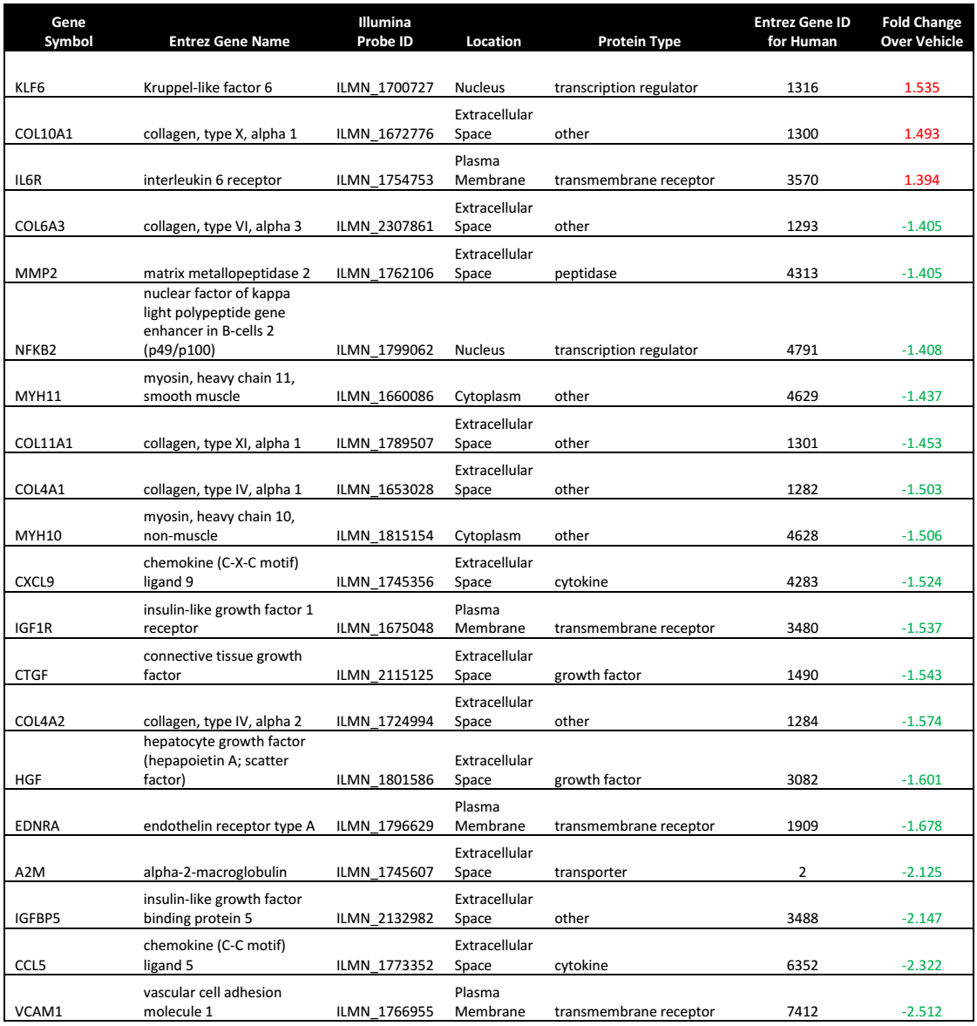

**Table 3:** Top 20 genes regulated by spearmint essential oil (SEO, 0.011% v/v) in the canonical hepatic fibrosis/hepatic stellate cell activation pathway. Fold change over vehicle was shown in log2 ratio form.

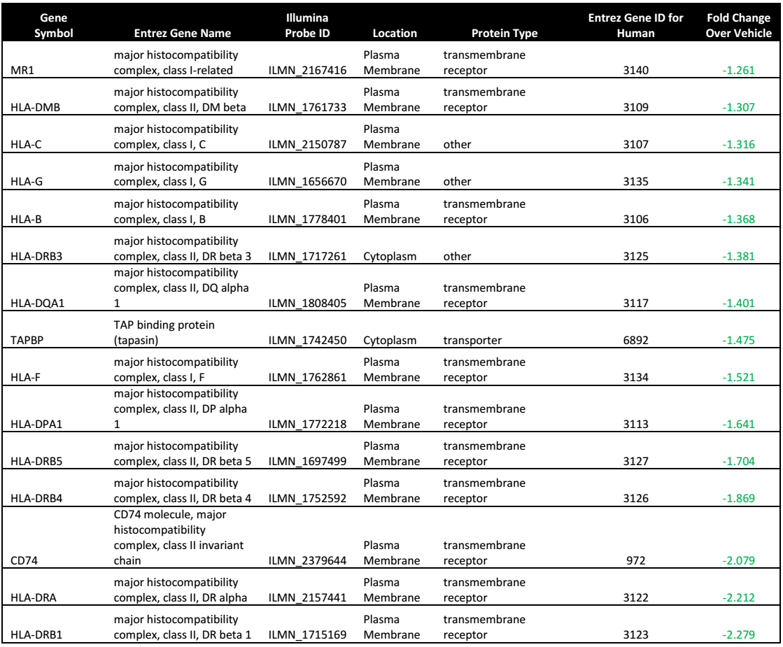

**Table 4:** Top 15 genes regulated by spearmint essential oil (SEO, 0.011% v/v) in the canonical antigen presentation pathway. Fold change over vehicle was shown in log2 ratio form.

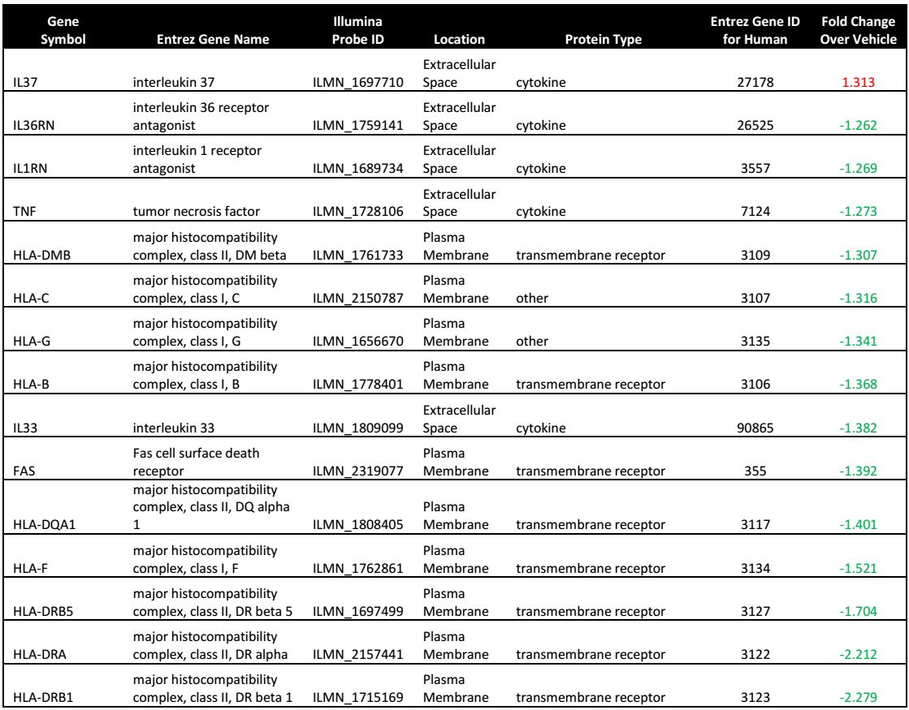

**Table 5:** Top 15 genes regulated by spearmint essential oil (SEO, 0.011% v/v) in the canonical graft-versus-host disease signaling pathway. Fold change over vehicle was shown in log2 ratio form.

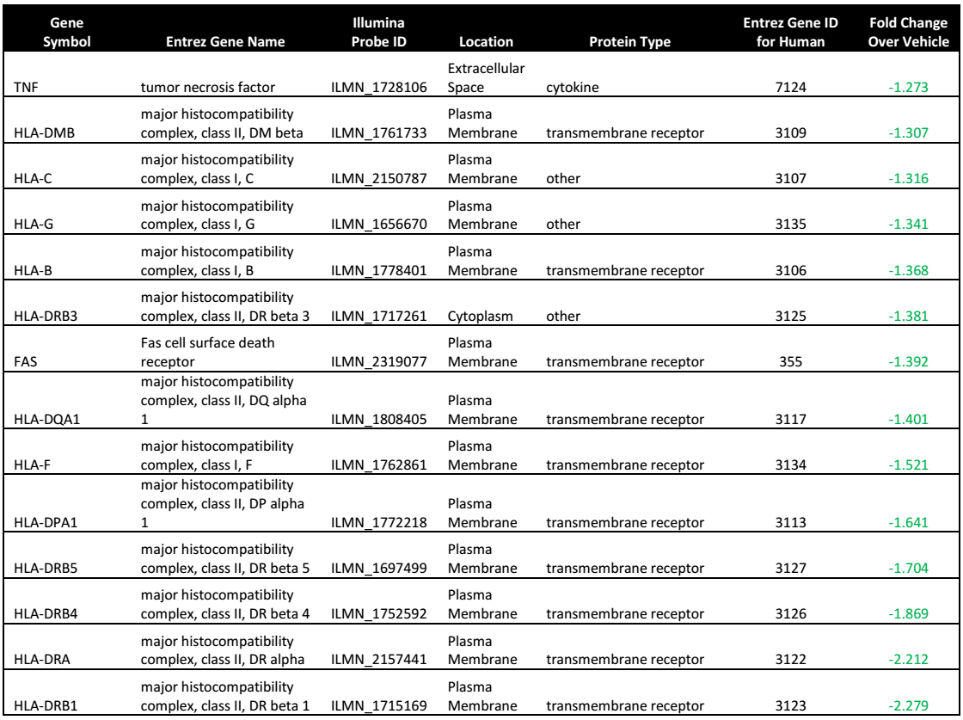

**Table 6:** Top 14 genes regulated by spearmint essential oil (SEO, 0.011% v/v) in the canonical allograft rejection signaling pathway. Fold change over vehicle was shown in log2 ratio form.