Supplementary File 1
Binary Logistic Regression

Binary logistic regression is used to identify a model to predict (1) Behavior Regulation Index (BRI) and (2) Metacognitive Index (MI) from a priori identified variables that have been identified to affect executive functioning (pain intensity, pain interference, anxiety, depression, body mass index [BMI], education and history of participating in contact sports).

Behavior Regulatory Index

The following tables presents results of binary logistic regression predicting BRI without selection showing unadjusted parameter estimates.

Analysis of Maximum Likelihood Estimates
Parameter |  | DF | Estimate | Standard  Error | Wald  Chi-Square | Pr > ChiSq
Intercept |  | 1 | 161.4 | 102.3 | 2.4858 | 0.1149
Contact Sport | 0 | 1 | -96.7225 | 57.3854 | 2.8409 | 0.0919
Contact Sport | 1 | 0 | 0 | . | . | .
Education |  | 1 | 21.8355 | 12.9325 | 2.8508 | 0.0913
BDI_b | 0 | 1 | 43.5718 | 27.4013 | 2.5285 | 0.1118
BDI_b | 1 | 0 | 0 | . | . | .
BAI_b | 0 | 1 | 152.5 | 88.7105 | 2.9543 | 0.0857
BAI_b | 1 | 0 | 0 | . | . | .
Age |  | 1 | 3.8145 | 2.2397 | 2.9007 | 0.0885
BMI_c |  | 1 | 4.4505 | 2.6617 | 2.7958 | 0.0945
Pain Intensity |  | 1 | 4.4143 | 3.4834 | 1.6059 | 0.2051
Pain Interference |  | 1 | 11.8225 | 6.9765 | 2.8717 | 0.0901

Unadjusted Odds Ratio Estimates
Effect | Point Estimate | 95% Wald  Confidence Limits
Sport 0 vs 1 | <0.001 | <0.001 | >999.999
Education | >999.999 | 0.030 | >999.999
BDI_b 0 vs 1 | <0.001 | <0.001 | >999.999
BAI_b 0 vs 1 | >999.999 | <0.001 | >999.999
Age | 0.022 | <0.001 | 1.778
BMI_c | 85.669 | 0.465 | >999.999
Pain Intensity | 82.623 | 0.090 | >999.999
Pain Interference | <0.001 | <0.001 | 6.367

Our next step is to run the same model with all variables using backward selection at selection entry and exclusion level at p=0.05. The following tables present results of this model. Pain interference, anxiety and BMI were significant predictors of BRI, where as all others were sequentially removed.

Analysis of Maximum Likelihood Estimates
Parameter |  | DF | Estimate | Standard  Error | Wald  Chi-Square | Pr > ChiSq
Intercept |  | 1 | -10.4989 | 6.1431 | 2.9209 | 0.0874
BAI_b | 1 | 1 | 5.0268 | 1.9435 | 6.6898 | 0.0097
BAI_b | 1 | 0 | 0 | . | . | .
BMI_c |  | 1 | 0.4769 | 0.2304 | 4.2835 | 0.0385
Pain Interference |  | 1 | 2.898 | 0.1399 | 6.0830 | 0.0136

Odds Ratio Estimates
Effect | Point Estimate | 95% Wald  Confidence Limits
BAI_b 0 vs 1 | 152.451 | 3.379 | >999.999
BMI_c | 1.611 | 1.026 | 2.531
Pain Interference | 1.412 | 1.073 | 1.8587

Summary of Backward Elimination
Step | Effect  Removed | DF | Number  In | Wald  Chi-Square | Pr > ChiSq | Variable  Label
1 | Pain Intensity | 1 | 7 | 1.6059 | 0.2051 | Pain Intensity
2 | BDI_b | 1 | 6 | 1.3326 | 0.2483 | BDI_b
3 | Education | 1 | 5 | 0.8070 | 0.3690 | Education
4 | Sport | 1 | 4 | 1.2653 | 0.2607 | Sport
5 | Age | 1 | 3 | 2.8430 | 0.0918 | Age

The next step is to assess collinearity, we performed correlation analysis (Pearson) between the three significant predictors and all three were significantly correlated.

Pearson Correlation Coefficients, N = 42
Prob > |r| under H0: Rho=0
 | BAI_b | BMI_c | PainInterference
BAI_b  BAI_b | 1.00000 | 0.49104  0.0010 | 0.48073  0.0013
BMI_c  BMI_c | 0.49104  0.0010 | 1.00000 | 0.44417  0.0032
PainInterference  PainInterference | 0.48073  0.0013 | 0.44417  0.0032 | 1.00000

Our next model will include all significant variables and interaction of significant variables. Results for this model are presented in the following table. All three interaction terms were not significant predictors and their r < 0.8 and were removed from the model.

Analysis of Maximum Likelihood Estimates
Parameter |  | DF | Estimate | Standard  Error | Wald  Chi-Square | Pr > ChiSq
Intercept |  | 1 | -10.4989 | 6.1431 | 2.9209 | 0.0874
BAI_b | 1 | 1 | 5.0268 | 1.9435 | 6.6898 | 0.0097
BAI_b | 1 | 0 | 0 | . | . | .
BMI_c |  | 1 | 0.4769 | 0.2304 | 4.2835 | 0.0385
Pain Interference |  | 1 | 2.899 | 0.1399 | 6.0830 | 0.0136

Odds Ratio Estimates
Effect | Point Estimate | 95% Wald  Confidence Limits
BAI_b 0 vs 1 | 152.451 | 3.379 | >999.999
BMI_c | 1.611 | 1.026 | 2.531
Pain Interference | 1.412 | 1.073 | 1.8587

Summary of Backward Elimination
Step | Effect  Removed | DF | Number  In | Wald  Chi-Square | Pr > ChiSq | Variable  Label
1 | BMI_c*BAI_b | 1 | 5 | 0.0259 | 0.8722
2 | Pain Interferen*BAI_b | 1 | 4 | 0.1636 | 0.6859
3 | BMI_c*Pain Interferen | 1 | 3 | 1.3514 | 0.2450

Hence, our final model only includes the three significant variables. Model fit characteristics of this model are presented below.

Association of Predicted Probabilities and Observed Responses
Percent Concordant | 96.3 | Somers' D | 0.926
Percent Discordant | 3.7 | Gamma | 0.926
Percent Tied | 0.0 | Tau-a | 0.293
Pairs | 272 | c | 0.963

On cross validation, the accuracy of the model decreases from 0.963 to 0.871.

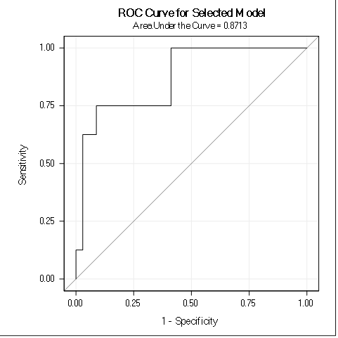
Association of Predicted Probabilities and Observed Responses
Percent Concordant | 87.1 | Somers' D | 0.743
Percent Discordant | 12.9 | Gamma | 0.743
Percent Tied | 0.0 | Tau-a | 0.235
Pairs | 272 | c | 0.871

Metacognition

The following tables presents results of binary logistic regression predicting MI without selection.

Analysis of Maximum Likelihood Estimates
Parameter |  | DF | Estimate | Standard  Error | Wald  Chi-Square | Pr > ChiSq
Intercept |  | 1 | -24.6404 | 296.8 | 0.0069 | 0.9338
Sport | 0 | 1 | 2.8551 | 3.5763 | 0.6373 | 0.4247
Sport | 1 | 0 | 0 | . | . | .
Education |  | 1 | 4.0101 | 3.0021 | 1.7843 | 0.1816
BDI_b | 0 | 1 | 25.0160 | 296.6 | 0.0071 | 0.9328
BDI_b | 1 | 0 | 0 | . | . | .
BAI_b | 0 | 1 | 8.7025 | 7.0252 | 1.5345 | 0.2154
BAI_b | 1 | 0 | 0 | . | . | .
Age |  | 1 | -0.2016 | 0.1546 | 1.7001 | 0.1923
BMI_c |  | 1 | -0.1609 | 0.3412 | 0.2224 | 0.6372
Pain Intensity |  | 1 | 2.7123 | 2.5944 | 1.0930 | 0.2958
Pain Interference |  | 1 | 2.322 | 0.4427 | 0.9458 | 0.3308

Odds Ratio Estimates
Effect | Point Estimate | 95% Wald  Confidence Limits
Sport 0 vs 1 | 17.376 | 0.016 | >999.999
Education | 55.151 | 0.154 | >999.999
BDI_b 0 vs 1 | >999.999 | <0.001 | >999.999
BAI_b 0 vs 1 | >999.999 | 0.006 | >999.999
Age | 0.817 | 0.604 | 1.107
BMI_c | 0.851 | 0.436 | 1.662
Pain Intensity | 0.864 | 0.193 | >999.999
Pain Interference | 0.650 | 0.273 | 1.548

Our next step is to run the same model with all variables using backward selection at selection entry and exclusion level at p=0.05. The following tables present results of this model. Pain interference was the only significant predictor of MI, whereas all others were sequentially removed.

Analysis of Maximum Likelihood Estimates
Parameter | DF | Estimate | Standard  Error | Wald  Chi-Square | Pr > ChiSq
Intercept | 1 | 4.1213 | 1.1312 | 13.2733 | 0.0003
Pain Interference | 1 | 3.8715 | 1.0831 | 9.6571 | 0.0019

Odds Ratio Estimates
Effect | Point Estimate | 95% Wald  Confidence Limits
Pain Interference | 1.295 | 1.100 | 1.524

Summary of Backward Elimination
Step | Effect  Removed | DF | Number  In | Wald  Chi-Square | Pr > ChiSq | Variable  Label
1 | BDI_b | 1 | 7 | 0.0071 | 0.9328 | BDI_b
2 | Sport | 1 | 6 | 0.0082 | 0.9277 | Sport
3 | BMI_c | 1 | 5 | 0.4226 | 0.5156 | BMI_c
4 | Age | 1 | 4 | 0.5347 | 0.4646 | Age
5 | Education | 1 | 3 | 2.9238 | 0.0873 | Education
6 | BAI_b | 1 | 2 | 3.0989 | 0.0783 | BAI_b
7 | Pain Intensity | 1 | 1 | 2.6888 | 0.1011 | Pain Intensity

Since there was only one significant predictor, no collinearity analysis was performed. Model fit of this model is presented below.

Association of Predicted Probabilities and Observed Responses
Percent Concordant | 81.2 | Somers' D | 0.692
Percent Discordant | 12.0 | Gamma | 0.742
Percent Tied | 6.7 | Tau-a | 0.274
Pairs | 341 | c | 0.846

On cross validation, the accuracy of the model decreases from 0.812 to 0.772.
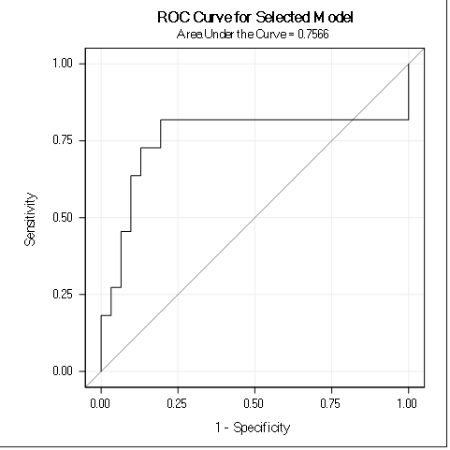
Association of Predicted Probabilities and Observed Responses
Percent Concordant | 75.7 | Somers' D | 0.513
Percent Discordant | 24.3 | Gamma | 0.513
Percent Tied | 0.0 | Tau-a | 0.203
Pairs | 341 | c | 0.757

