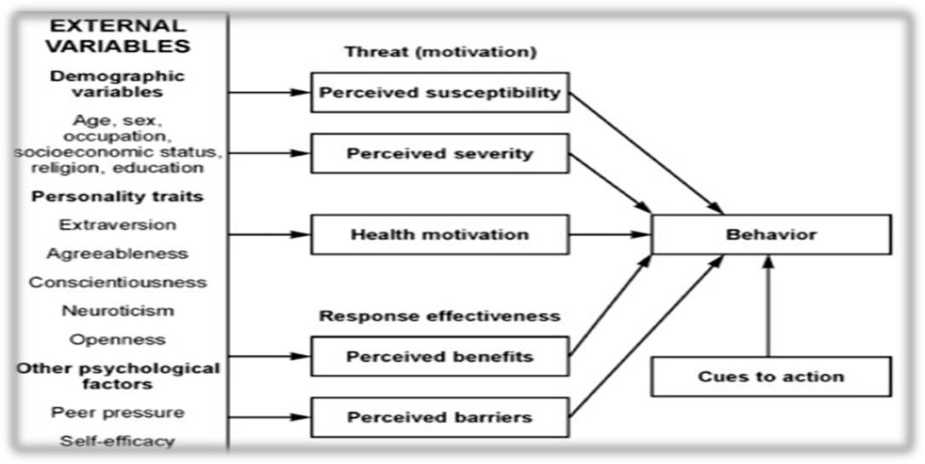

Appendix A: Health Belief Model.
Note: The health belief model (HBM) was developed in the 1950s by social psychologists Irwin Rosenstock, Godfrey Hochbaum, S. Stephen Kegeles, and Howard Leventhal at the U.S. Public Health Service to better understand the failure of screening programs for individuals with tuberculosis. This model is based on the theory that an individual’s willingness to modify their health behavior is due to variables, motivation, and perceived effectiveness. According to perceived susceptibility, individuals will change behaviors if deemed at risk. Perceived severity is the probability an individual will change behaviors to avoid consequences based on how serious they consider the consequence to be. According to perceived benefits, individuals will change a behavior if it is beneficial. According to perceived barriers, changing health behaviors can create physical and financial difficulties as well as loss of time. Modifying variables, perceptions, or influences, such as the individual’s demographics, are psychosocial and structural variables. Two other elements—cues to action and self-efficacy—reinforce what it takes to get an individual to change. Cues to action motivate a person from the desire to change. Self-efficacy examines an individual’s belief or faith in their ability to change the behavior [35].

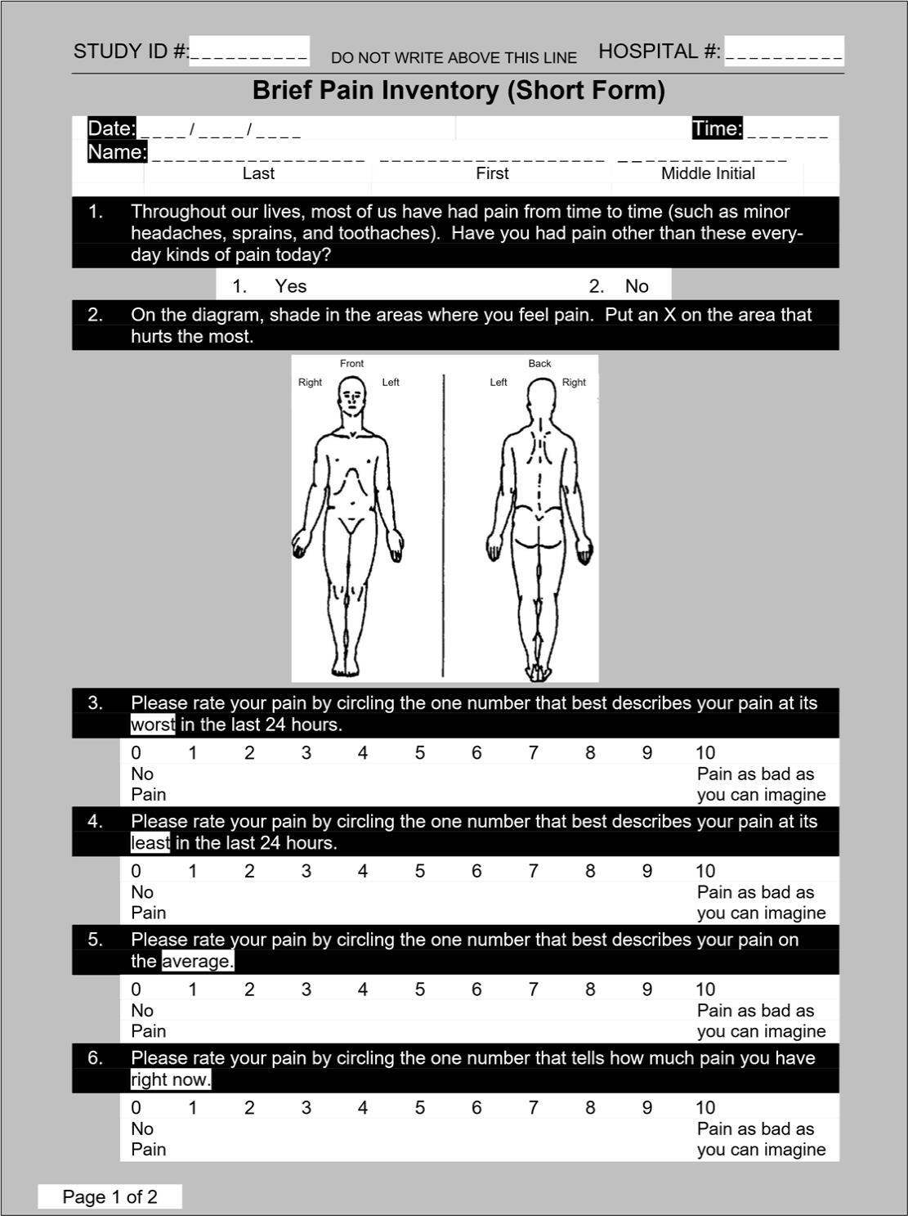
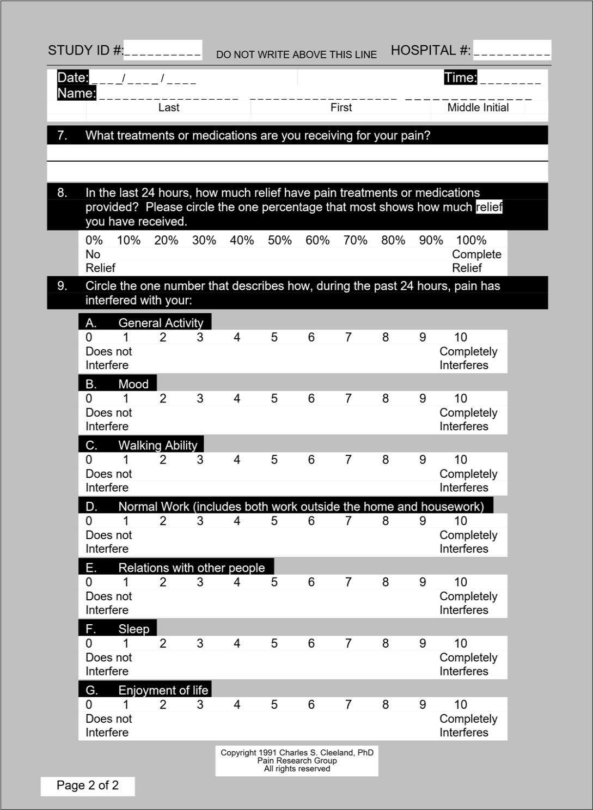

Appendix B: Brief Pain Inventory Tool.
Note: This is a condensed sample of the Brief Pain Inventory survey by Cleeland (1991). Clients respond to the BPI using a 10-point Likert scale to describe and label pain location, activities of daily living, and personal responses.

Introduction: The Use of Medical Marijuana for the Relief of Chronic Pain

You may be able to take part in a research study. This form provides important information about that study, including the risks and benefits to you as a potential participant. Please listen carefully as the researcher reads the information. Please feel free to ask the researcher any questions that you may have about the study. You may ask about research activities and any risks or benefits you may experience. You may also wish to discuss your participation with other people, such as your family doctor or a family member.

Your participation in this research is entirely voluntary. You may refuse to participate or stop your participation at any time and for any reason without any penalty or loss of benefits to which you are otherwise entitled.

PURPOSE AND DESCRIPTION:

This research is being done to determine how medical cannabis influences pain relief and if medical cannabis influences the number of opioids (for example morphine, oxycodone, OxyContin) administered. You are being asked to take part in this study because you are someone certified to purchase medical cannabis in the state of Maryland and who suffer from chronic pain. There are no direct benefits to you for taking part in the study. Your participation will contribute to the study results and possible help for chronic pain sufferers in the future. Information gathered in this study may assist other providers, patients, and stakeholders to make decisions that could impact the future of medical cannabis in your state.

If you agree to participate, you will be asked to attend one telephone health visit with the researcher and the visit is expected to take 15-20 minutes. During this visit, you will be asked to participate in the following procedures:

The completion of the study will involve a team approach, with BPCC assistance from Dr. Charles Weng, managerial assistance from Ms. Layla Salah and ACU committee chair and members. The study results will improve client care and outcomes with the education of medical cannabis awareness and usage to other providers and clinicians looking to support clients in their search for chronic pain relief.

RISKS & BENEFITS:

The primary risk is breach of confidentiality, but we have taken measure to minimize this risk. This is a serious risk but is very unlikely. Those measures are described in the next section. There are potential benefits to participating in this study such as an increased understanding of medical cannabis for the relief of chronic pain.

PRIVACY & CONFIDENTIALITY:

Any information you provide will be confidential to the extent allowable by law. Some identifiable data may have to be shared with individuals outside of the study team, such as members of the ACU Institutional Review Board at The University, Abilene Christian has certain rules and guidelines to protect information about you. There are federal and state laws to protect your privacy.

Generally, only the people on the research team will know that you are participating in the study and will see your information-name, age, and demographic information. Other individuals associated to ACU may see or give out your information, such as the secondary or supporting investigator and other ACU staff involved in the IRB process. We cannot do this study without your permission to use and give out your information. We will use and disclose your information only as described in this form and in our Privacy Notice Practices.

Confidentially, protection will be provided by protecting, storing, and encrypting client names and contact information or identifiers within the computer database or removed from the database during data analysis.

Data used and submitted for analysis will be destroyed prior to project completion and data surveyed will not be linked to the study participant. De-identified data acquired during this scholarly project will be stockpiled in a secure university drive with the project researcher’s name. The data will be securely stored on campus for a 3-year period following the completion of the study, and then destroyed.

CONTACTS:

If you have questions about the research study, the lead researcher is Jacquelyn Paylor, CRNP, DNP-Student and may be contacted at XXXXXXXXXXXX, XXXXXXXXXXXX. If you are unable to reach the lead researcher or wish to speak to someone other than the lead researcher, you may contact Dr. Lynn McClellan, Faculty Advisor, XXXXXXXXXXXX. If you have concerns about this study, believe you may have been injured because of this study, or have general questions about your rights as a research participant, you may contact ACU’s Chair of the Institutional Review Board and Executive Director of Research, Megan Roth, Ph.D. Dr. Roth may be reached at XXXXXXXXXXXX XXXXXXXXXXXX 328 Hardin Administration Building, ACU Box 29103 Abilene, TX 79699
Additional Information

There will be a minimum of 25 participants enrolled in the study.

There may be unexpected risks associated with your participation in this study and some of those may be serious. We will notify you if any such risks are identified throughout the course of the study which may affect your willingness to participate. Participation is voluntary. You can leave at any time. Leaving the study will not affect your medical cannabis certification. If you would like to withdraw from the study, please tell the principal investigator, Jacquelyn Paylor, right away.

Your participation may be ended early by the researchers for certain reasons. For example, we may end your participation if you no longer meet study requirements, the researchers believe it is no longer in your best interest to continue participating, you do not follow the instructions provided by the researchers, or the study is ended. You will be contacted by the researchers and given further instructions if you are removed from the study.

There will be no cost to participate in this study.

There will be no reimbursement for study participation.

Participants may request study results with the conclusion of written study.

Please let the researchers know if you are participating in any other research studies at this time.

69

Consent Signature Section

Participant verbal consent will be obtained during the telephone health care visit. The researcher will note that verbal consent was given by the participant over the telephone.

Researcher Notes:

Participant provided verbal telephone consent:

Yes ________ No _________
Appendix C: Consent to Participate in Study.

Patient Initials

Gender Identity

Age

Phone Number
Highest Education/Profession

Type of Cannabis Preferred

Years of Medical Cannabis Use_________________________________

Opioid Usage? If yes, please name.

Appendix D: Patient Demographic Form.
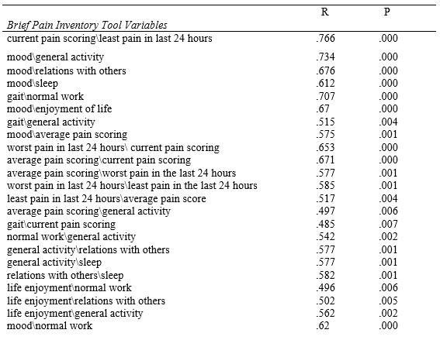

Appendix E: Pain Correlations.

Note. This table includes the statistical results and p value of Pearson’s r.

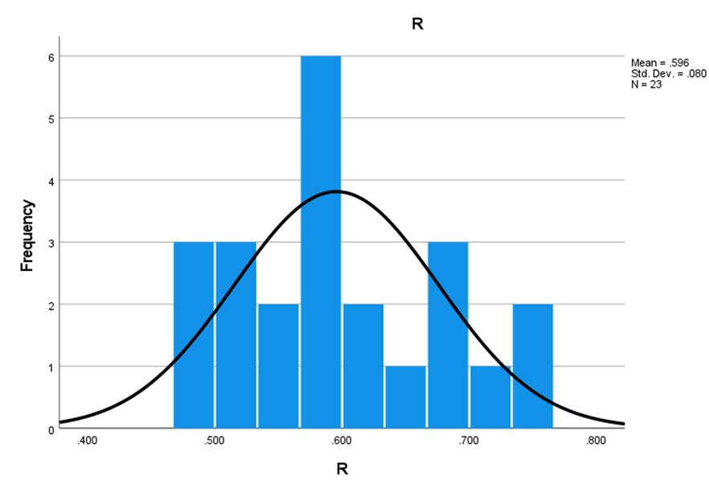

Appendix F: Pearson’s r Bell Curve.
Note: Histogram depiction of Pearson’s r values and frequency of variable correlations from the BPI tool.

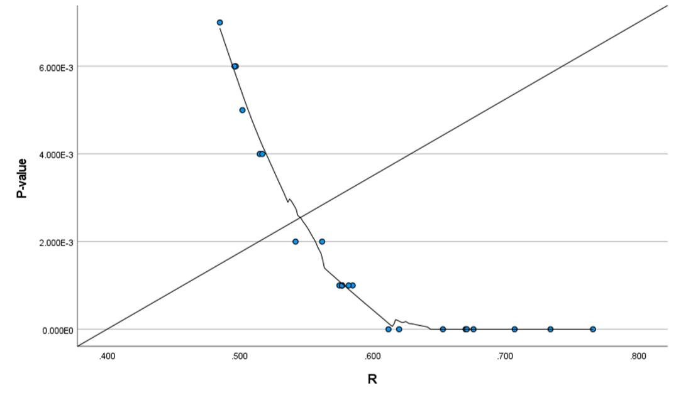

Appendix G: Pearson’s LOESS Regression.
Note: Scatterplot incorporation of LOESS polynomial regression with BPI variable linear correlation of fluctuating relationships.

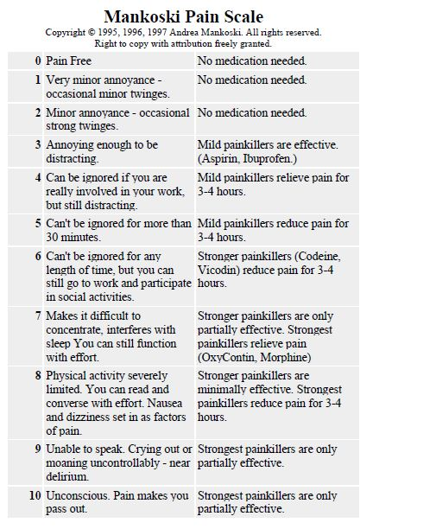
Appendix H: Mankoski Pain Scale.
Note: “I devised this pain scale to help me describe the subjective experience of pain in more concrete terms to my doctors and family. Please feel free to use it and distribute it with attribution” [43].

2019-Summer I—Origination of Topic: The Use of Medical Marijuana for the Relief of Chronic Pain

04/09/20—PICOT Question and Search Strategy 04/14/20—Formation of the Project Committee 04/16/20—Approval of the DNP Project Mini Proposal 05/19/20—Training—Human Subjects Research/IRB 2020 May—Permission for Study Location
2020 May—Survey Tool and Revision Chapters 1–3

2020 June—Survey Permission Letter

06/29/20—Permission to Schedule Proposal Defense

10/15/20—Project Proposal Defense and Evaluation

12/08/20—BPI Tool License Agreement

04/21/21—IRB #21-033 Approval Exempt Category 3

04/25/21—Start of Study, Open Survey

05/25/21—End of Study, Final Survey

06/07/21—Inactivation of Current Study

07/06/21—Rough Draft—Chapters 1–5

07/12/21—Defense Copy of Scholarly Project Sent to Committee 07/12/21—Defense Visual PowerPoint Presentation Sent to Committee 07/12/21—Scheduling of Final Defense 07/12/21—Doodle Poll Final Defense

07/13/21—Doodle Poll Consensus August 5, 2021, 1400—Final Defense
Appendix I: Project Timeline.

